School-Age Child Care
PrimeTime
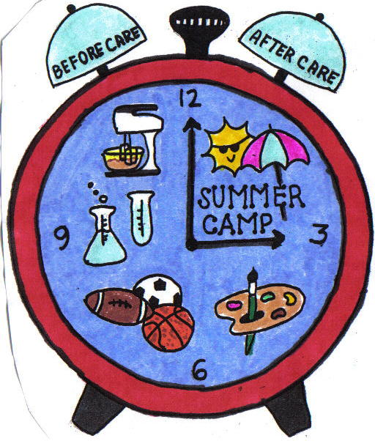
11 Springfield Avenue
Cranford, NJ 07016
908-276-3088
Lisa Decker, Director

Employment Application

Applicant Information
Last Name |  |  |  |  |  |  | First |  |  |  | M.I. |  |  | Date
Street Address |  |  |  |  |  |  |  |  |  |  | Apartment/Unit #
City |  |  |  |  |  | State |  |  |  |  | ZIP
Birth Date |  |  |  |  |  |  | Phone
Date Available |  |  |  |  |  |  | Social Security No.
Position Applying For:
Have you ever been convicted of a felony? YES NO
If YES, please explain:

Education
High School: |  |  |  |  |  |  | Address
From |  |  |  | To | Did you graduate? |  | YES |  | NO | Degree
College: |  |  |  |  |  |  | Address
From |  |  |  | To | Did you graduate? |  | YES |  | NO | Degree
Other: |  |  |  |  |  |  | Address
From |  |  |  | To | Did you graduate? |  | YES |  | NO | Degree

References
Please list at least two references from former employees or other persons who have knowledge of your work experience and/or education.
1.Full Name |  |  |  |  |  |  |  | Relationship
Company |  |  |  |  |  |  |  | Phone ( )
Address
2.Full Name |  |  |  |  |  |  |  | Relationship
Company |  |  |  |  |  |  |  | Phone ( )
Address
3.Full Name |  |  |  |  |  |  |  | Relationship
Company |  |  |  |  |  |  |  | Phone ( )
Address

Previous Employment
1.Company |  |  |  |  |  |  |  |  | Phone | ( )
Address |  |  |  |  |  |  |  |  | Supervisor
Job Title |  |  |  |  |  | Starting Salary $ |  |  |  |  |  | Ending Salary $
Responsibilities
From: |  |  | To: |  | Reason for Leaving
2.Company |  |  |  |  |  |  |  |  | Phone | ( )
Address |  |  |  |  |  |  |  |  | Supervisor
Job Title |  |  |  |  |  | Starting Salary $ |  |  |  |  |  | Ending Salary $
Responsibilities
From: |  |  | To: |  | Reason for Leaving
3.Company |  |  |  |  |  |  |  |  | Phone | ( )
Address |  |  |  |  |  |  |  |  | Supervisor
Job Title |  |  |  |  |  | Starting Salary $ |  |  |  |  |  | Ending Salary $
Responsibilities
From: |  |  | To: |  | Reason for Leaving

Disclaimer and Signature
I have received and read the center’s philosophy on the disciplining of children. YES
I have received and read the Information to Parent’s Statement. YES

I certify that my answers are true and complete to the best of my knowledge. If this application leads to employment, I understand that false or misleading information in my application or interview
may result in my release.
Signature Date:

For center’s use only: reference verification
Name:____________________________________ Date:_________________________
Comments:__________________________________________________________________
__________________________________________________________________________
__________________________________________________________________________
__________________________________________________________________________

Name:____________________________________ Date:____________________________
Comments:__________________________________________________________________
__________________________________________________________________________
__________________________________________________________________________
__________________________________________________________________________
Hire Date:__________________________Position:__________________________________________
Date of Termination:________________________Reasons:____________________________________

